

**ExEED – Research Based Learning**

**G. NIKHITHA -**

**20951A6226@iare.ac.in**

**P. NANDINI –**

**20951A6224@iare.ac.in**

SMART MANAGEMENT SYSTEM FOR CAFETERIA

**Index:**

1. Abstract
2. Introduction
3. Literature Review
4. Methodology
   * Includes Flowchart / algorithm
   * Block diagrams
   * Explanation about Technology used, algorithms
   * Explanation about system considered / data taken / real time system you are working for the project
5. Results and Discussion
6. References

**ABSTRACT**

Customer satisfaction is the key to success for any business. In a restaurant, the traditional hand-waving method for calling services is inefficient often leading to many complaints. The Restaurant Management System increases operational efficiency through use of an internal wired communications system. The communications system increases customer satisfaction by leaving a system at each table which the customer can use to request for a server. This system allows managers and owners to easily monitor restaurant functions and employee progress.

In many popular restaurants, waiters/waitress tend to miss out on tables or customers’ calls during busy hours potentially decreasing ones clientele. While this is an ongoing issue, there is still no product that drastically improves the communication between the servers and the customers in the current market. Hence, the goal is to design a system in which the customers can call their servers easily and help the restaurant increase overall efficiency.

**Keywords:** Operational efficiency, Online based system.

# INTRODUCTION

At present traders maintain their day to day products calculations where a waiter has to go at each table and takes the order. And give to the chef and they must be passed to the cashier. During this process it takes lots of time and customer must wait till the process Only single system is used during this process.

In this application we are calculating the amount of items which are selected by the customer. This application is based on the Water fall model. This application is platform dependent. This application is introduced in Windows platform. In this we have only one screen or one window. This application is used in Café shops. In this application we have different types of Cafe food items and drinks.

**This application will reduce the time required for barrier or server taking orders from customers. This application is developed using Python programming language. In this we used different type of Modules.**

**Café**, also spelled **cafe**, small eating and drinking establishment, historically a [coffeehouse](https://www.britannica.com/topic/coffee), usually featuring a limited menu; originally these establishments served only [coffee](https://www.britannica.com/topic/coffee). The English term café, borrowed from the French, derives ultimately from the Turkish kahve, meaning coffee. The introduction of coffee and coffee drinking to [Europe](https://www.britannica.com/place/Europe) provided a much-needed focus for the social activities of the sober. The first café is said to have opened in 1550 in Constantinople; during the 17th century cafés opened in [Italy](https://www.britannica.com/place/Italy), [France](https://www.britannica.com/place/France), [Germany](https://www.britannica.com/place/Germany), and [England](https://www.britannica.com/place/England)

# Literature Review

|  |  |  |  |
| --- | --- | --- | --- |
| **S No** | **Title Of the Paper** | **Author &amp; Publication defaults** | **Key Observation** |
| **1.** | An Integrated System for Café Management | Campos, J. and Muñoz, V. | Cafe Manager system offers comprehensive features for efficient cafe management, including inventory control, sales tracking, and staff management. The system improves operational efficiency and provides better decision-making capabilities for café owners. |
| **2.** | Cafe Management System: A Web-based Application for Efficient Management of Cafeterias | Chowdhury, S. and Sarkar, S. | The web-based cafe management system facilitates streamlined operations, such as order management, inventory tracking, and billing. <br> - The application enables efficient resource utilization and improved customer service. |
| **3.** | Development of a Cafe Management System Using RFID Technology | Kumbhar, R., et al. | RFID-based cafe management system enables automatic identification of items, leading to enhanced inventory management and reduced manual errors. <br> - The system improves operational efficiency and ensures accurate billing and tracking of café resources |
| **4.** | Design and Implementation of Cafe Management System Based on Internet of Things | Pratama, D. A. and Nugroho, A. S. | IoT-based cafe management system offers real-time monitoring and control of cafe resources, including inventory, temperature, and customer preferences. <br> - The system enhances operational efficiency, enables personalized customer experiences, and supports remote management capabilities. |

**Methodology**

**SDLC Model**

Introduction:

The System Development Life Cycle (SDLC), or Software Development Life Cycle in systems engineering, information systems and software engineering, is the process of creating or altering systems, and the models and methodologies that people use to develop these systems. In software engineering the SDLC concept underpins many kinds of software development methodologies form the framework for planning and controlling the creation of an information system the software development process.

PROCESS MODEL USED WITH JUSTIFICATION

SDLC (Waterfall Model):

The Waterfall model is the earliest SDLC approach that was used for software development.

The waterfall Model illustrates the software development process in a linear sequential flow. This means that any phase in the development process begins only if the previous phase is complete. In this waterfall model, the phases do not overlap.

Waterfall approach was first SDLC Model to be used widely in Software Engineering to ensure success of the project. In “The Waterfall” approach, the whole process of software development is divided into separate phases. In this Waterfall model, typically, the outcome of one phase acts as the input for the next phase sequentially.

The Waterfall Model was the first Process Model to be introduced. It is also referred to as a **linear-sequential life cycle model**. It is very simple to understand and use. In a waterfall model, each phase must be completed before the next phase can begin and there is no overlapping in the phases.

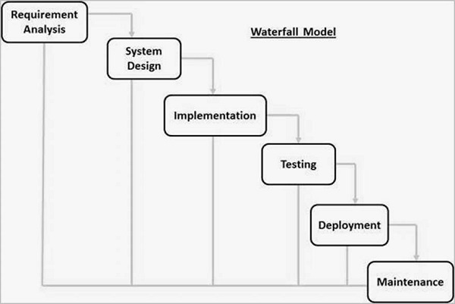

Stages in SDLC :

* **Requirement Gathering and analysis** – All possible requirements of the system to be developed are captured in this phase and documented in a requirement specification document.

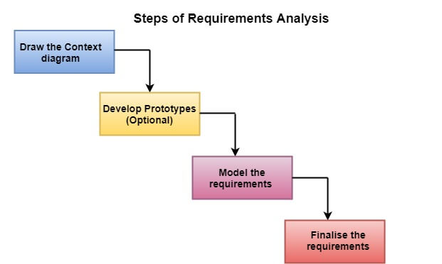

* **System Design** – The requirement specifications from first phase are studied in this phase and the system design is prepared. This system design helps in specifying hardware and system requirements and helps in defining the overall system architecture

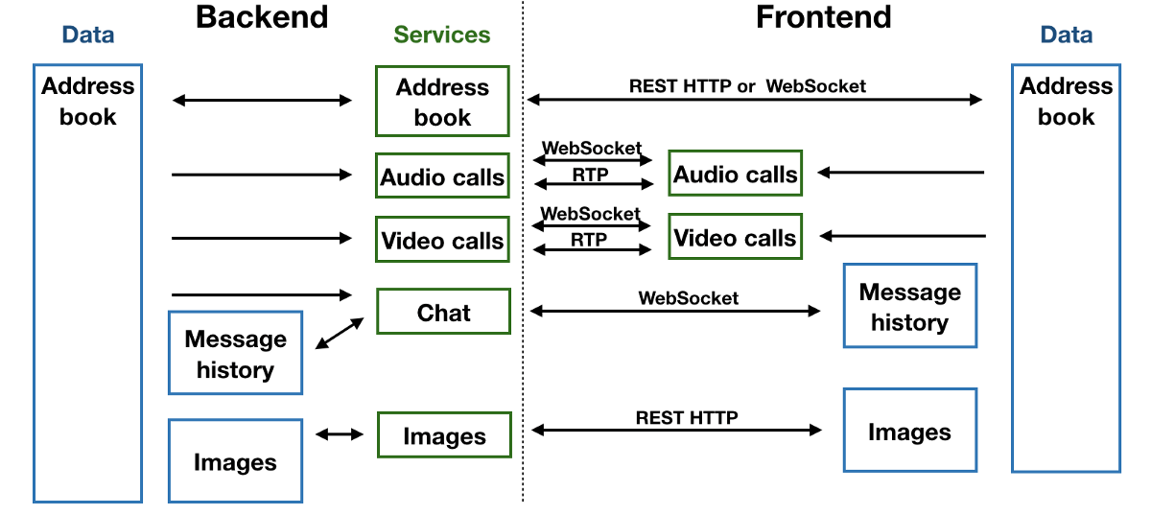

* **Implementation** – With inputs from the system design, the system is first developed in small programs called units, which are integrated in the next phase. Each unit is developed and tested for its functionality, which is referred to as Unit Testing.

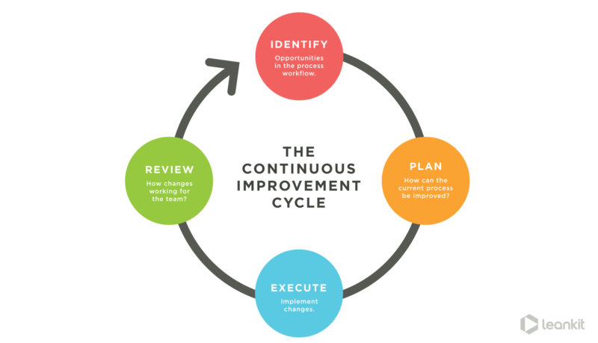

* **Integration and Testing** – All the units developed in the implementation phase are integrated into a system after testing of each unit. Post integration the entire system is tested for any faults and failures.

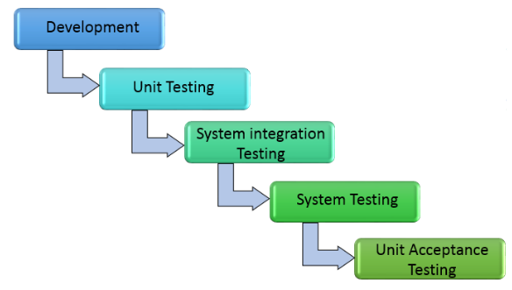

* **Deployment of system** – Once the functional and non-functional testing is done; the product is deployed in the customer environment or released into the market.

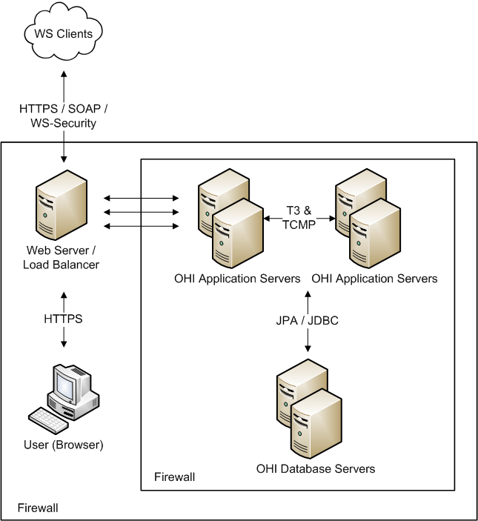

* **Maintenance** – There are some issues which come up in the client environment. To fix those issues, patches are released. Also to enhance the product some better versions are released. Maintenance is done to deliver these changes in the customer environment.

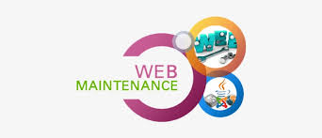

Modules:

In this application we are selecting the items and entering the quantity of items. Calculating the amount including paid tax and creating receipt for the items and printing the receipt. For this application we use Modules of Python that is,

**Tkinter :-** For the outer look and widgets used in application. Tkinter is Python's de-facto standard GUI (Graphical User Interface) package. It is a thin object-oriented layer on top of [Tcl/Tk](http://www.tcl.tk/).

Tkinter is not the only [GuiProgramming](https://wiki.python.org/moin/GuiProgramming) toolkit for Python. It is however the most commonly used one. [CameronLaird](https://wiki.python.org/moin/CameronLaird) calls the yearly decision to keep TkInter "one of the minor traditions of the Python world."

**OS :-** Used to print the receipt.

An operating system (OS) is [system software](https://en.wikipedia.org/wiki/System_software) that manages [computer hardware](https://en.wikipedia.org/wiki/Computer_hardware), [software](https://en.wikipedia.org/wiki/Computer_software) resources, and provides common [services](https://en.wikipedia.org/wiki/Daemon_(computing)) for [computer programs](https://en.wikipedia.org/wiki/Computer_program).

[Time-sharing](https://en.wikipedia.org/wiki/Time-sharing) operating systems [schedule tasks](https://en.wikipedia.org/wiki/Scheduler_(computing)) for efficient use of the system and may also include accounting software for cost allocation of [processor time](https://en.wikipedia.org/wiki/Scheduling_(computing)), [mass storage](https://en.wikipedia.org/wiki/Mass_storage), printing, and other resources.

**DateTime :-** Used to show current date in receipt

A date in Python is not a data type of its own, but we can import a module named datetime to work with dates as date objects.

HARDWARE SYSTEM USED

* Processor : Intel Core(TM) i5
* RAM : 8.00 GB
* Key Board : Standard Windows Keyboard
* System type : 64-bit operating system

SOFTWARE SYSTEM USED

* Operating system : Windows 11
* Coding Language : Python
* Front-End : Python
* Designing : Python

# RESULTS:

**INPUT:**

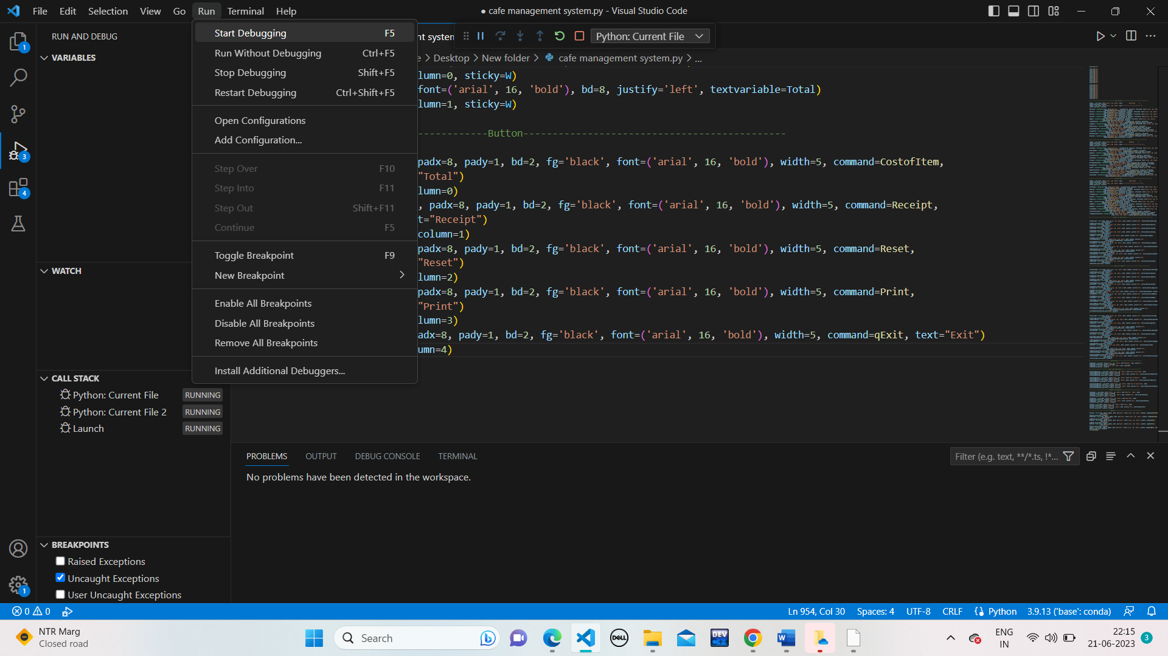

# OUTPUT:

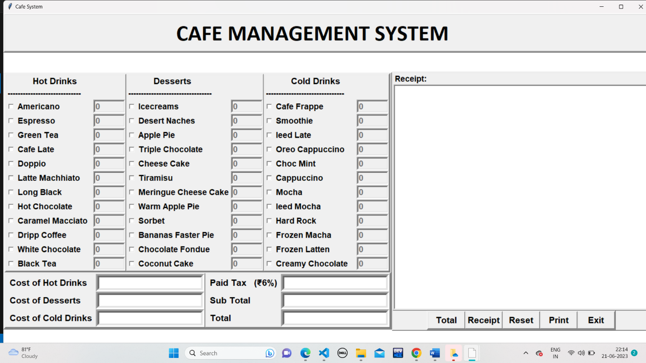

**CONCLUSION:**

In this project, we made an application which is used in Coffee shops. This project proposed design and developed to order the items in Coffee shop. In this application we given print option to print receipt of orders which is given by customers. Coffee is one of the source to heal any stress. In this application customers order their food at their table without having barrier.

# REFERENCES*:*

* 1. *Minal Patil, Krushna Chetepawad, Ashwanikumar Shahu and Shivshankar Swami, "IOT based smart car parking system", IJARIIE, 2020.*
  2. *Shantashree Das and Debomalya Ghose, "Influence of online food delivery Apps on The operations of The Restaurant Business",*International Journal of Scientific and technology Research*, vol. 8, no. 12, December 2019, ISSN 2277-8616.*
  3. *Rajalakshmi Vel and P. C. Lakshmi Narayanan, "Start-Up to Stardom: An Access of the Growth of E-Ticketing Firm Book My Show",*International Journal of Innovative Technology and Exploring Engineering (IJITEE)*, vol. 8, no. 11S, September 2019, ISSN 2278-3075.*
  4. *Anita Vinaik, Richa Goel, Seema Sahai and Vikas Garg, "The study of Interest of consumers in mobile food ordering apps",*International Journal of Recent technology and Engineering (URTE)*, vol. 8, no. 1, May 2019, ISSN 22773878.*